**Lab2. Creating anonymous blocks**

1. Create 6 anonymous blocks for your database (Lab 1) with the functionality according to the database domain.
2. At least three blocks must include explicit cursors.
   1. For the cursors, use the traditional way of processing them two times and the *Cursor For Loop* structure – once.
   2. One of the cursors that you create needs to be with parameters.
   3. Cursors must be used correctly, according to their functionality!!!
3. Additionally, the anonymous blocks must include:
   1. creating and application of at least one record;
   2. creating and application of at least one INDEX BY table;
   3. application of the control structures, such as IF, loops, CASE.

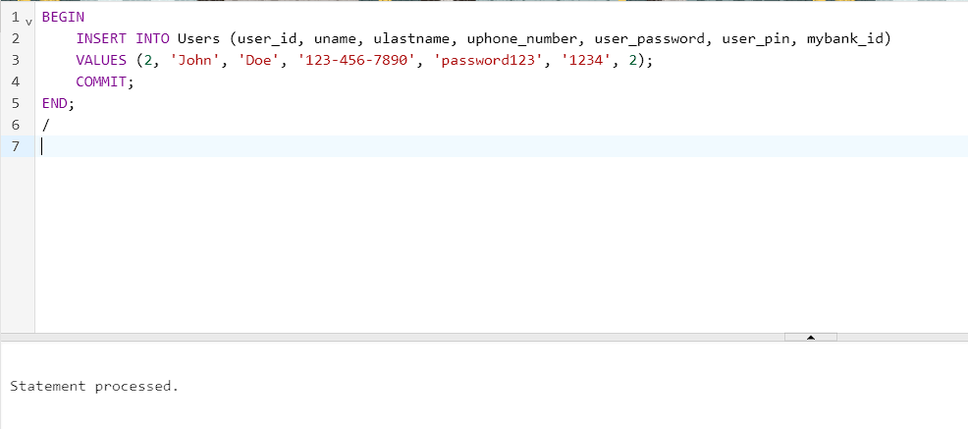

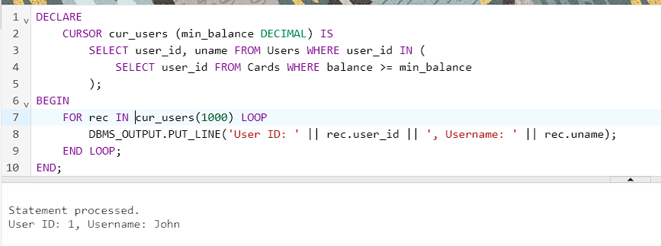

DECLARE

CURSOR cur_users (min_balance DECIMAL) IS

SELECT user_id, uname FROM Users WHERE user_id IN (

SELECT user_id FROM Cards WHERE balance >= min_balance

);

BEGIN

FOR rec IN cur_users(1000) LOOP

DBMS_OUTPUT.PUT_LINE('User ID: ' || rec.user_id || ', Username: ' || rec.uname);

END LOOP;

END;

/

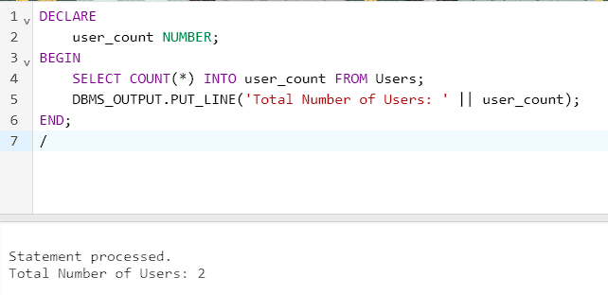

DECLARE

user_count NUMBER;

BEGIN

SELECT COUNT(*) INTO user_count FROM Users;

DBMS_OUTPUT.PUT_LINE('Total Number of Users: ' || user_count);

END;

/

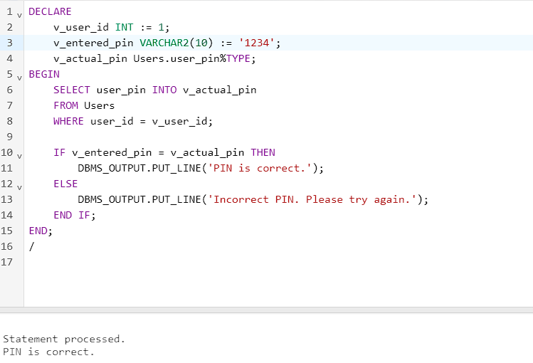

DECLARE

v_user_id INT := 1;

v_entered_pin VARCHAR2(10) := '1234';

v_actual_pin Users.user_pin%TYPE;

BEGIN

SELECT user_pin INTO v_actual_pin

FROM Users

WHERE user_id = v_user_id;

IF v_entered_pin = v_actual_pin THEN

DBMS_OUTPUT.PUT_LINE('PIN is correct.');

ELSE

DBMS_OUTPUT.PUT_LINE('Incorrect PIN. Please try again.');

END IF;

END;

/

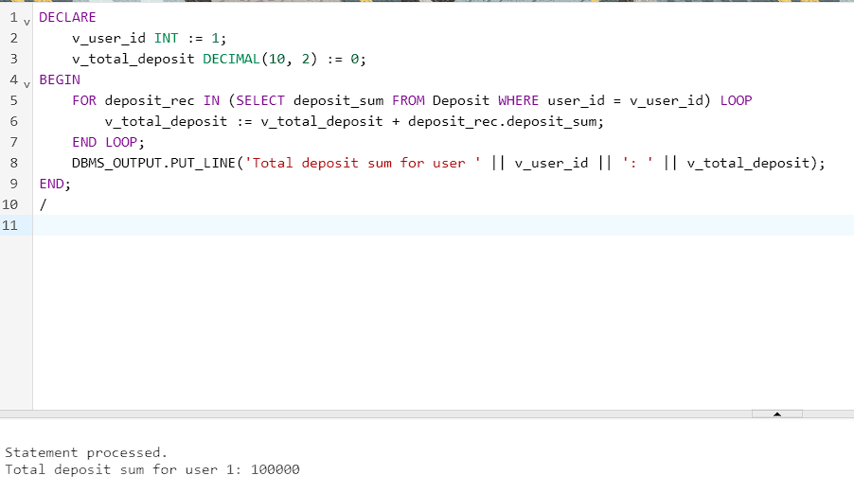

DECLARE

v_user_id INT := 1;

v_total_deposit DECIMAL(10, 2) := 0;

BEGIN

FOR deposit_rec IN (SELECT deposit_sum FROM Deposit WHERE user_id = v_user_id) LOOP

v_total_deposit := v_total_deposit + deposit_rec.deposit_sum;

END LOOP;

DBMS_OUTPUT.PUT_LINE('Total deposit sum for user ' || v_user_id || ': ' || v_total_deposit);

END;

/

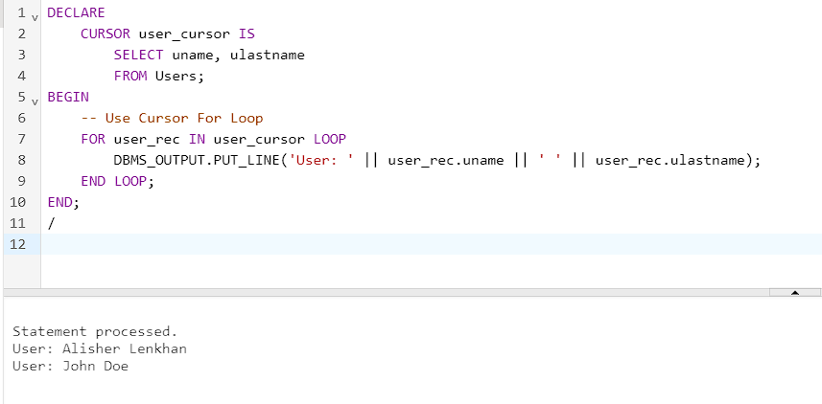

DECLARE

CURSOR user_cursor IS

SELECT uname, ulastname

FROM Users;

BEGIN

-- Use Cursor For Loop

FOR user_rec IN user_cursor LOOP

DBMS_OUTPUT.PUT_LINE('User: ' || user_rec.uname || ' ' || user_rec.ulastname);

END LOOP;

END;

/

Questions:

1. **Describe the structure of an anonymous block**

Anonymous block in PL/SQL consists of three sections: Declaration, Execution, Exception Handling.

1. **What types of blocks exist in PL/SQL?**

Anonymous Blocks: These are unnamed and standalone PL/SQL blocks that can be executed directly.

Named Blocks (Procedures and Functions): These are named and reusable blocks of code that can be called from other parts of the program.

1. **The rules to declare variables**

Variable names must start with a letter and can contain letters, numbers, and underscores.

Variable names are case insensitive.

Variables must have a data type specified.

Variables can be declared in the Declaration section of a block

1. **What types of composite data types do you know?**

Records: Used to hold related data items of different data types.

Nested Tables: Variable-size arrays.

VARRAYs (Variable Size Arrays): Fixed-size arrays.

1. **What is the main difference between records and INDEX BY tables?**

Records: Contain a fixed number of fields of different data types.

INDEX BY Tables (Associative Arrays): Are collections where data is stored as key-value pairs, and the size is dynamic.

1. **Show how to create records (2 ways)**

DECLARE

emp_rec RECORD_TYPE;

BEGIN

emp_rec.field1 := 'Value1';

emp_rec.field2 := 123;

END;

DECLARE

emp_rec RECORD_TYPE := RECORD_TYPE('Value1', 123);

BEGIN

emp_rec.field1

emp_rec.field2

END;

1. **Show how to create INDEX BY table**

DECLARE

TYPE index_by_table IS TABLE OF VARCHAR2(50) INDEX BY PLS_INTEGER;

my_table index_by_table;

BEGIN

my_table(1) := 'Value1';

my_table(2) := 'Value2';

END;

1. **The use of %TYPE attribute**

emp_name employees.first_name%TYPE;

1. **The use of %ROWTYPE attribute**

emp_record employees%ROWTYPE;

1. **The types of loops**
2. **The types of CASE**
3. **Implicit cursors and their attributes**

%FOUND, %NOTFOUND, %ROWCOUNT, %ISOPEN.

1. **Explicit cursors**

Explicit cursors are user-defined and must be declared, opened, fetched, and closed explicitly.

1. **The attributes of explicit cursors**

%FOUND, %NOTFOUND, %ROWCOUNT, %ISOPEN, and others

1. **What happens when we declare an explicit cursor?**

When declaring an explicit cursor, you specify the SQL query that the cursor will execute. The cursor is not yet associated with any result set.

1. **What happens when we open the explicit cursor?**

Opening an explicit cursor associates it with a specific result set based on the SQL query. It prepares the cursor for fetching rows.

1. **What happens when we fetch the explicit cursor?**

Fetching retrieves rows one at a time from the result set associated with the cursor. The fetched data can be processed or displayed.

1. **What happens when we close the explicit cursor?**

Closing a cursor releases resources and frees it from the associated result set. After closing, no more fetch operations can be performed on the cursor.